Ethan Perdieu
CIT-45100
Project Part 1
November 2nd, 2025

Process Map:
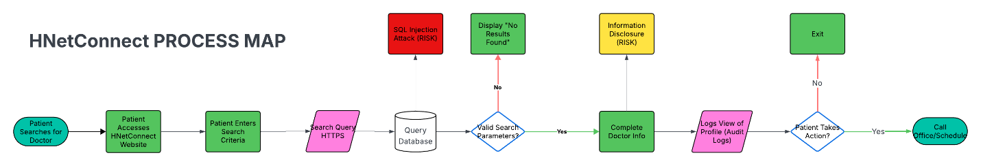
Asset Inventory:
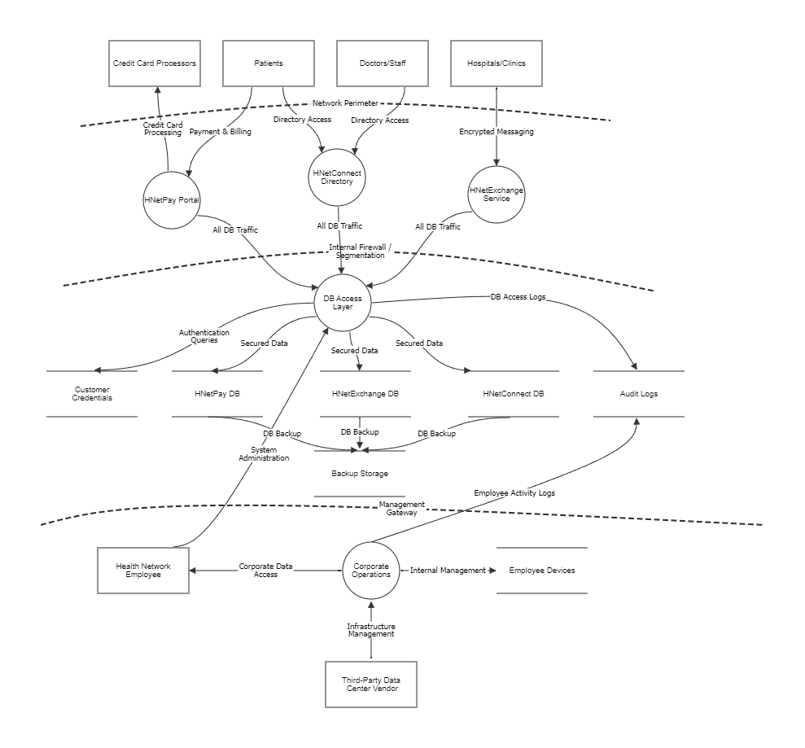
Asset Classification – Microsoft Threat Modeling Tool:
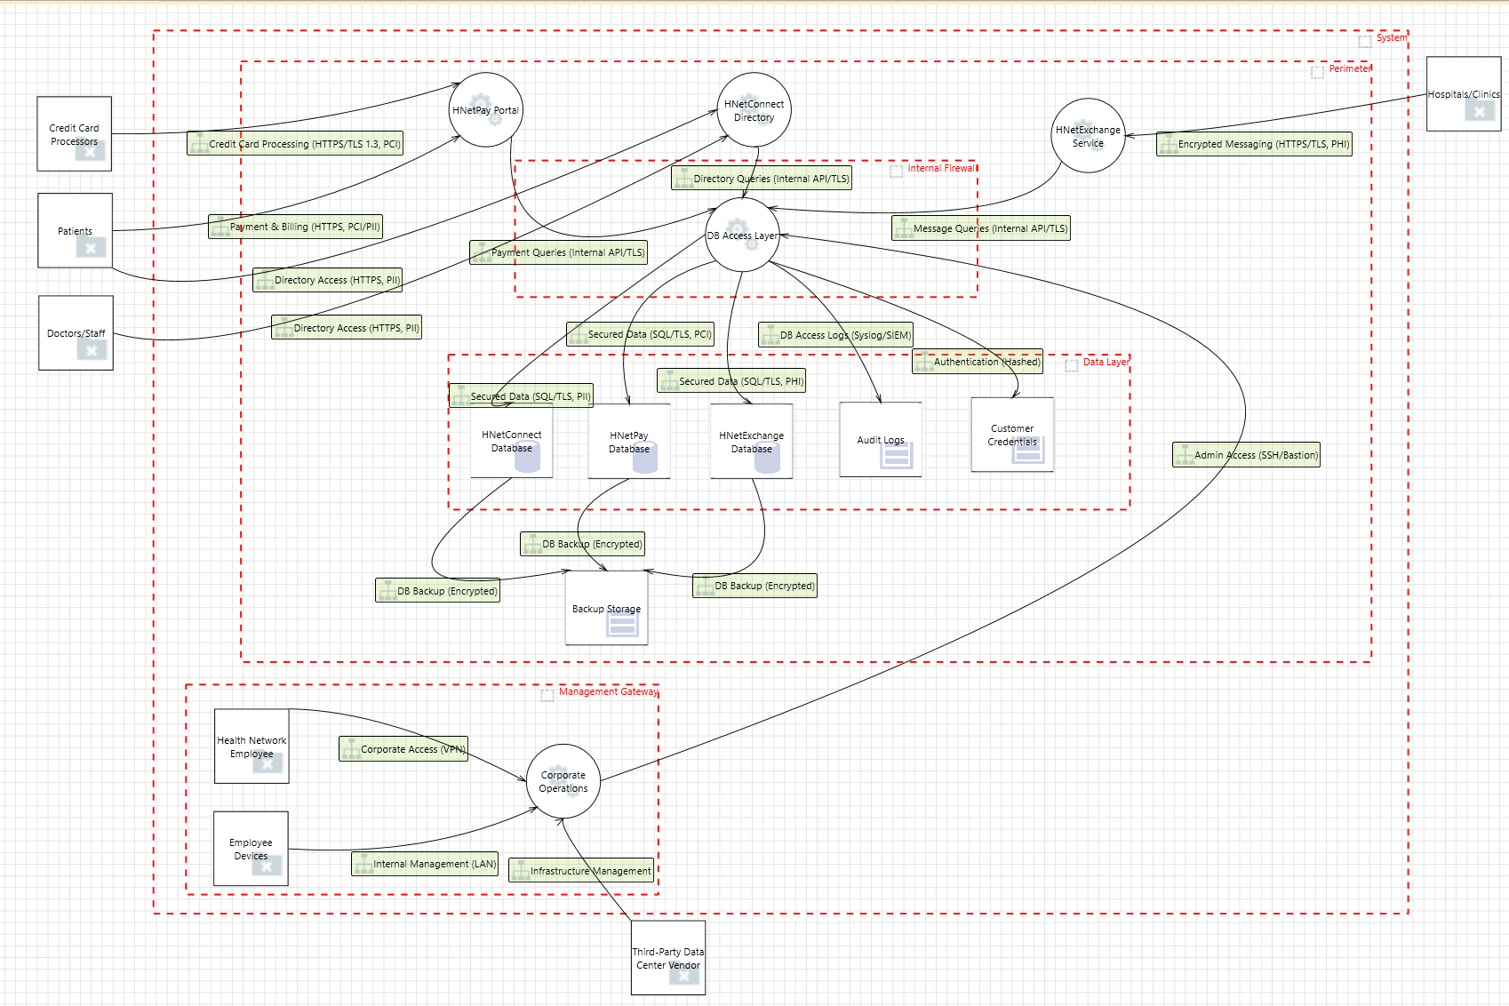
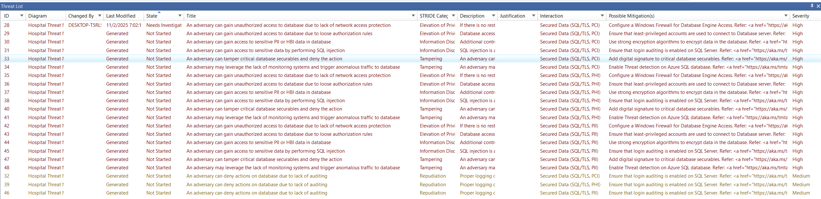

Microsoft Threat Modeling Tool Advantages:
- Very Intuitive Diagram Mapping
  - Uses a drag-and-drop interface with clear icons for data stores, processes, external entities, and data flows.
- In-Depth Threat Generation and Analysis
  - Automatically generates potential threats for each component or interaction and provides detailed mitigation suggestions based on Microsoft’s internal security knowledge base.
  - Offers links to documentation for development of countermeasures to threats
- Interactive Visual Feedback
  - When selecting a threat, the tool highlights the corresponding elements in the data flow diagram, helping users quickly locate affected components and understand context. This visual linking between diagram and threat list improves traceability and comprehension, especially in large models.
- Template and Reuse Support
  - Allows for reusing model templates across similar projects, saving setup time for systems with repeated architectures.

Microsoft Threat Modeling Tool Limitations:
- Clunky Boundary and Layout Adjustments
  - Moving trust boundaries or resizing diagram elements can feel unresponsive or cause layout misalignments.
  - The interface lacks modern auto-alignment or snapping features, making complex diagrams messy without manual adjustment.
- Cluttered Threat Presentation
  - The threat list pane can become crowded, especially in large systems with many data flows.
- Diagram-First, Threat-Analysis-Second Design
  - The tool prioritizes visual modeling over deeper analytical flexibility.

Asset Classification – Threat Composer:
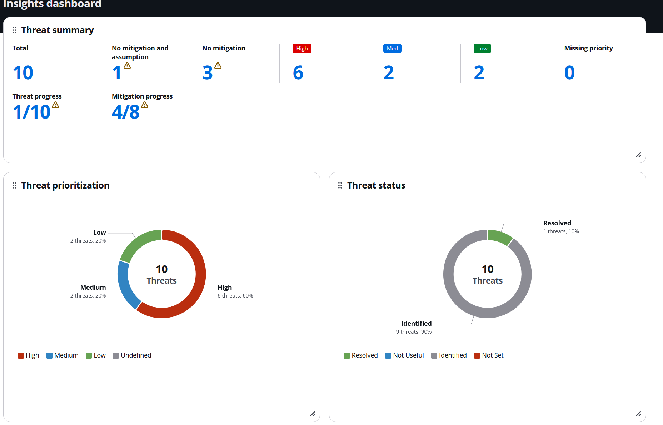
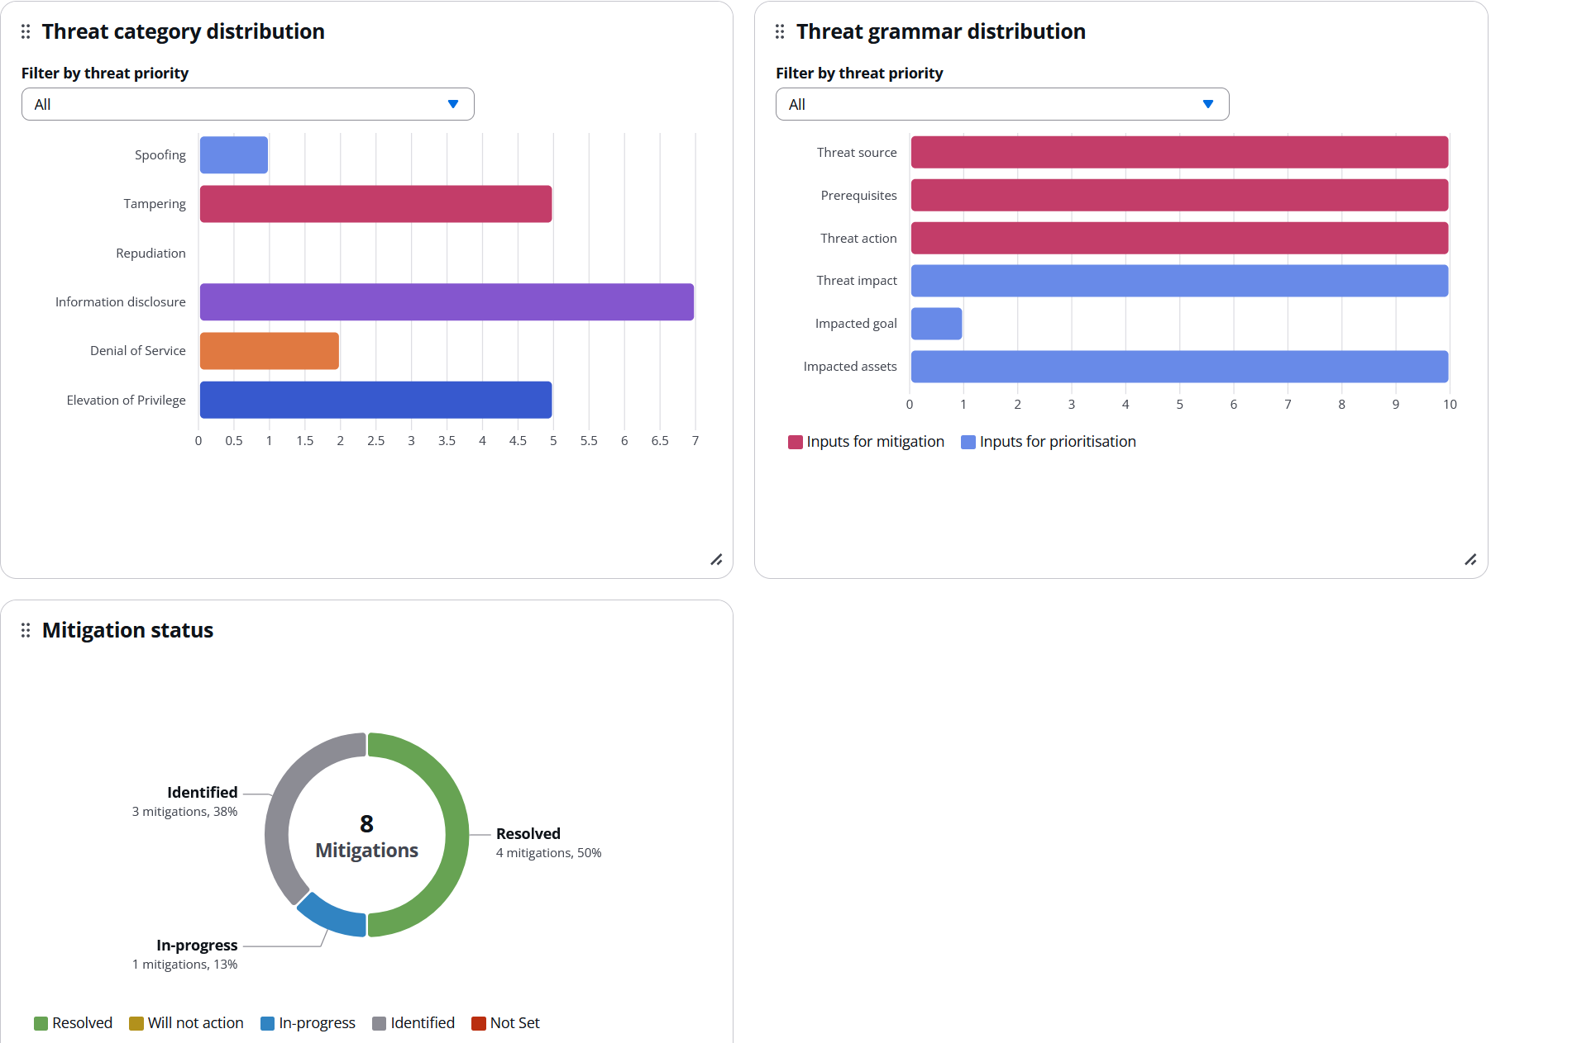
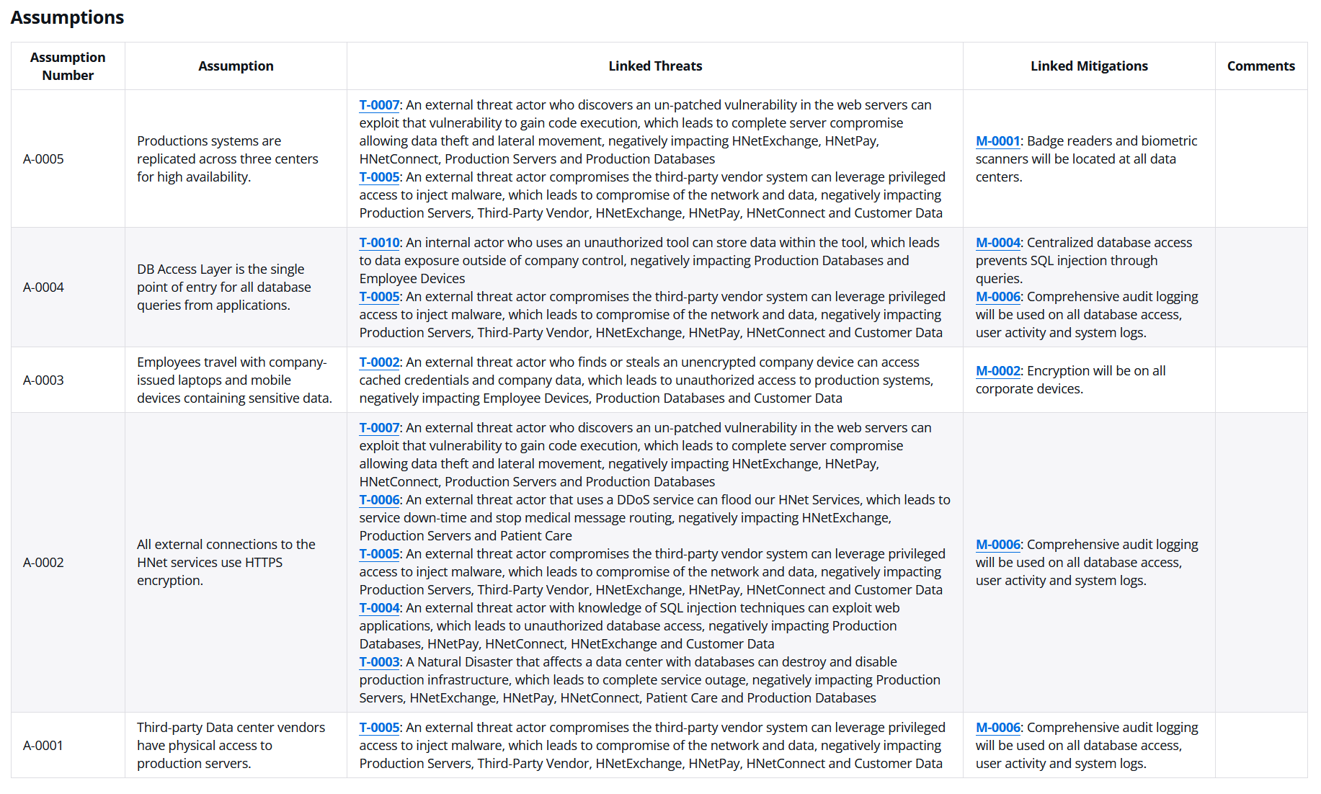
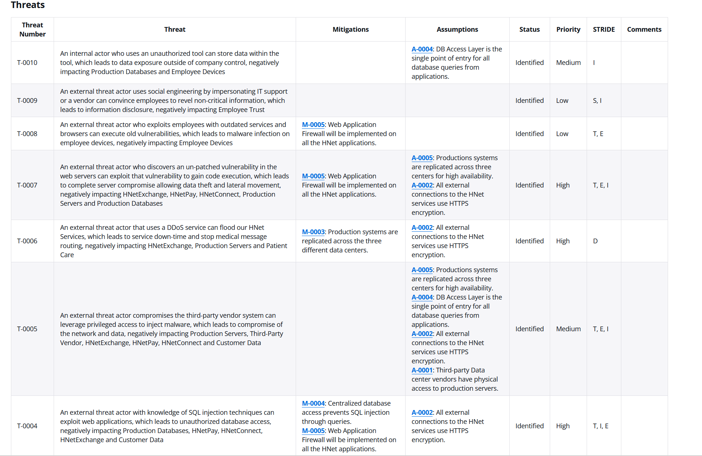
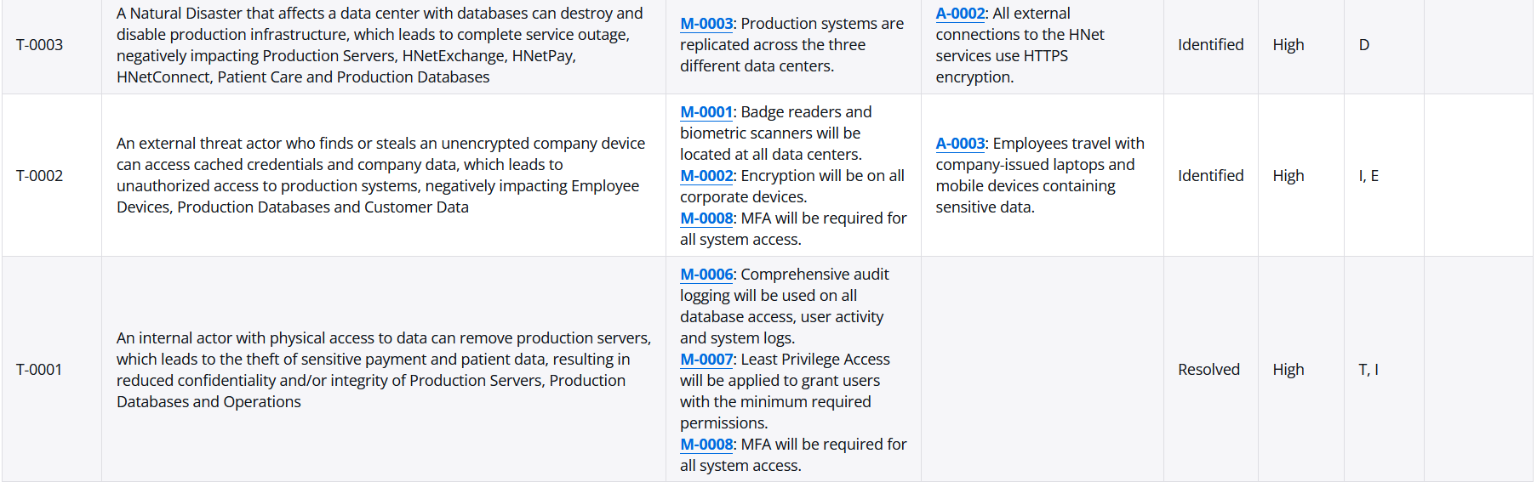
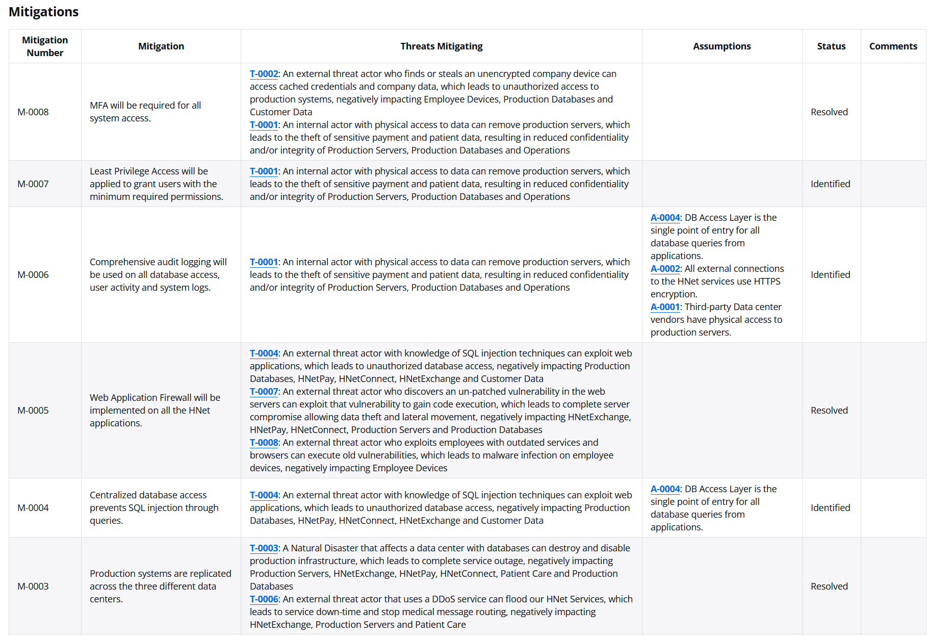
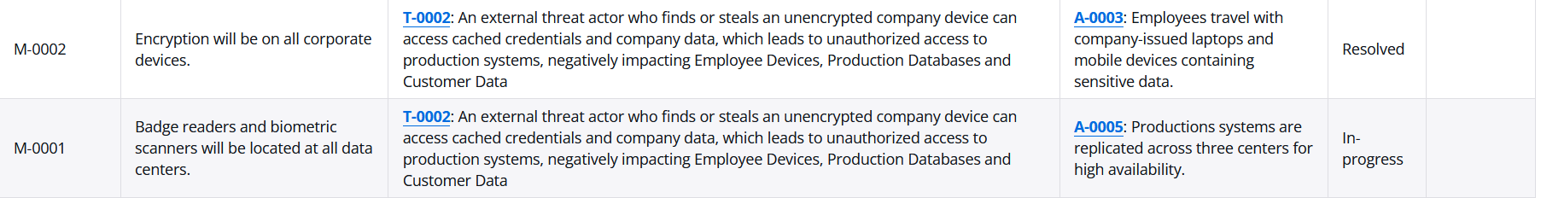
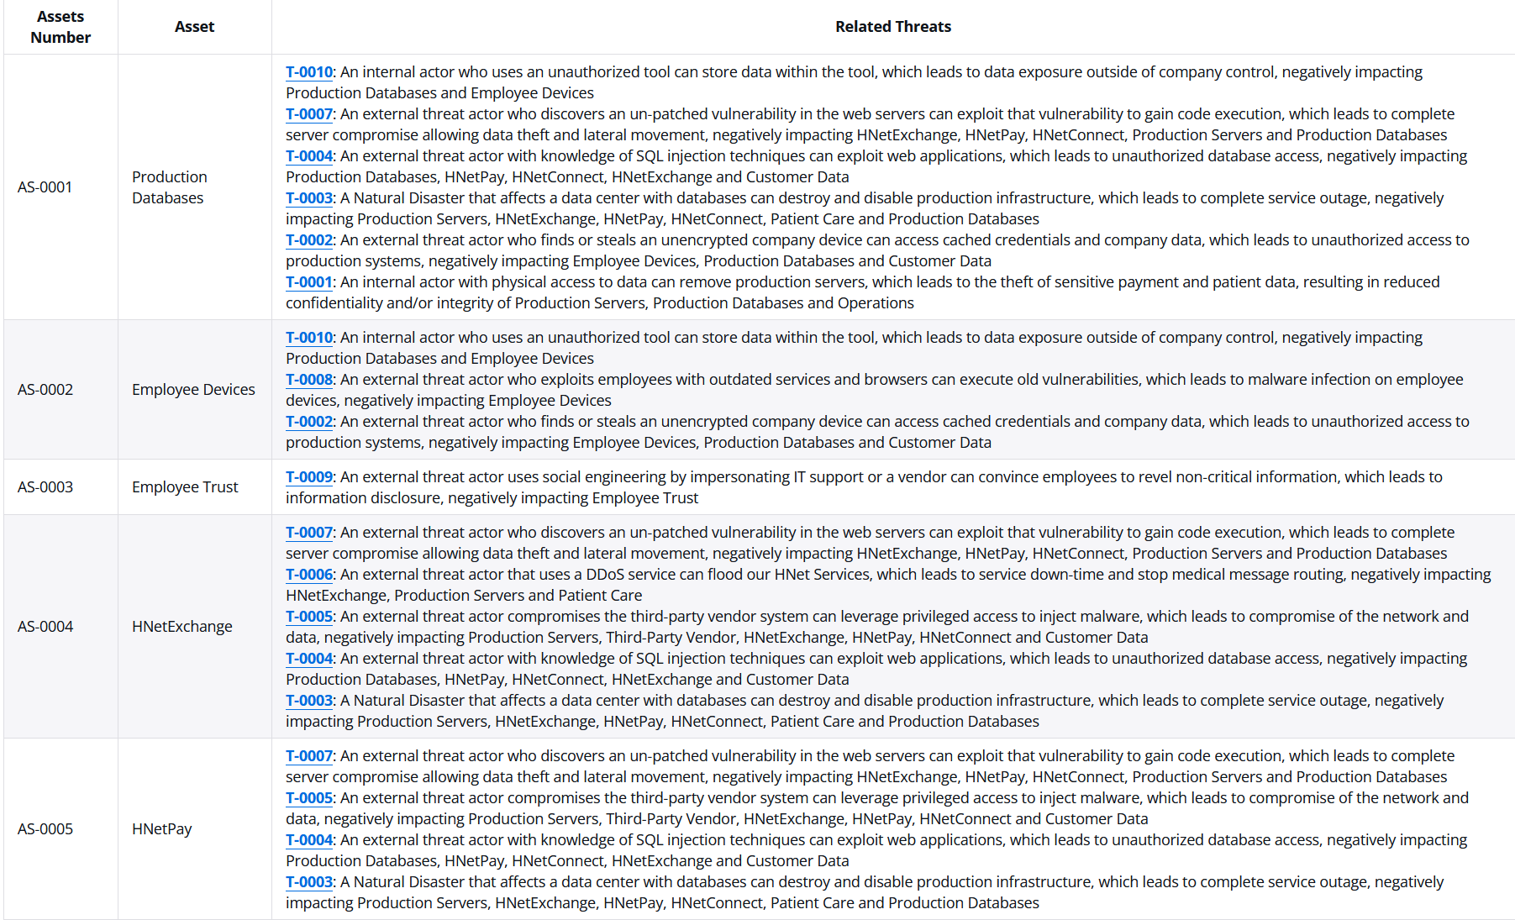
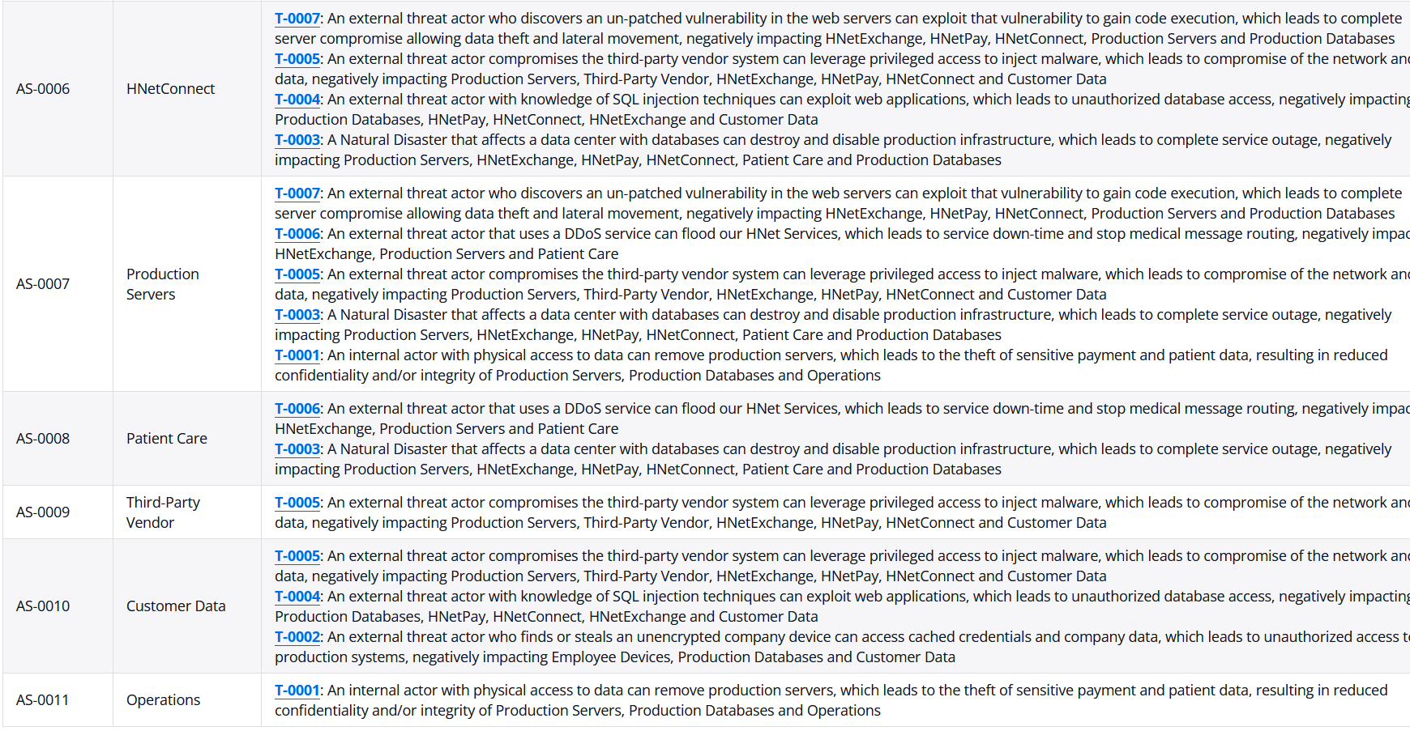

Threat Composer Advantages:
Forces you to think systematically by using a template:
“[Threat Source] [Prerequisites] can [Theat Action] which least to [Threat Impact], negatively impacting [Impacted Assets]”
- Web Based / No Installation
- Integrated Relationship Mapping
  - Linked Mitigations
  - Linked Assumptions
- Built-in STRIDE Classification
- Great Tagging and Filtering Capabilities
- Status Tracking and Severity Tracking

Threat Composer Limitations:
- Has no visual diagramming elements; Can’t create Data Flow Diagrams
- No Automatic Threat Generation
  - Must manually detect and write every identified threat
- Limited Collaboration Features
  - Multi-user editing is not possible, and you can’t assign certain threats to team members
- No way to visualize trust boundaries and other architectural components
- Limited File exporting
  - Only JSON exports

Vulnerability Scan:
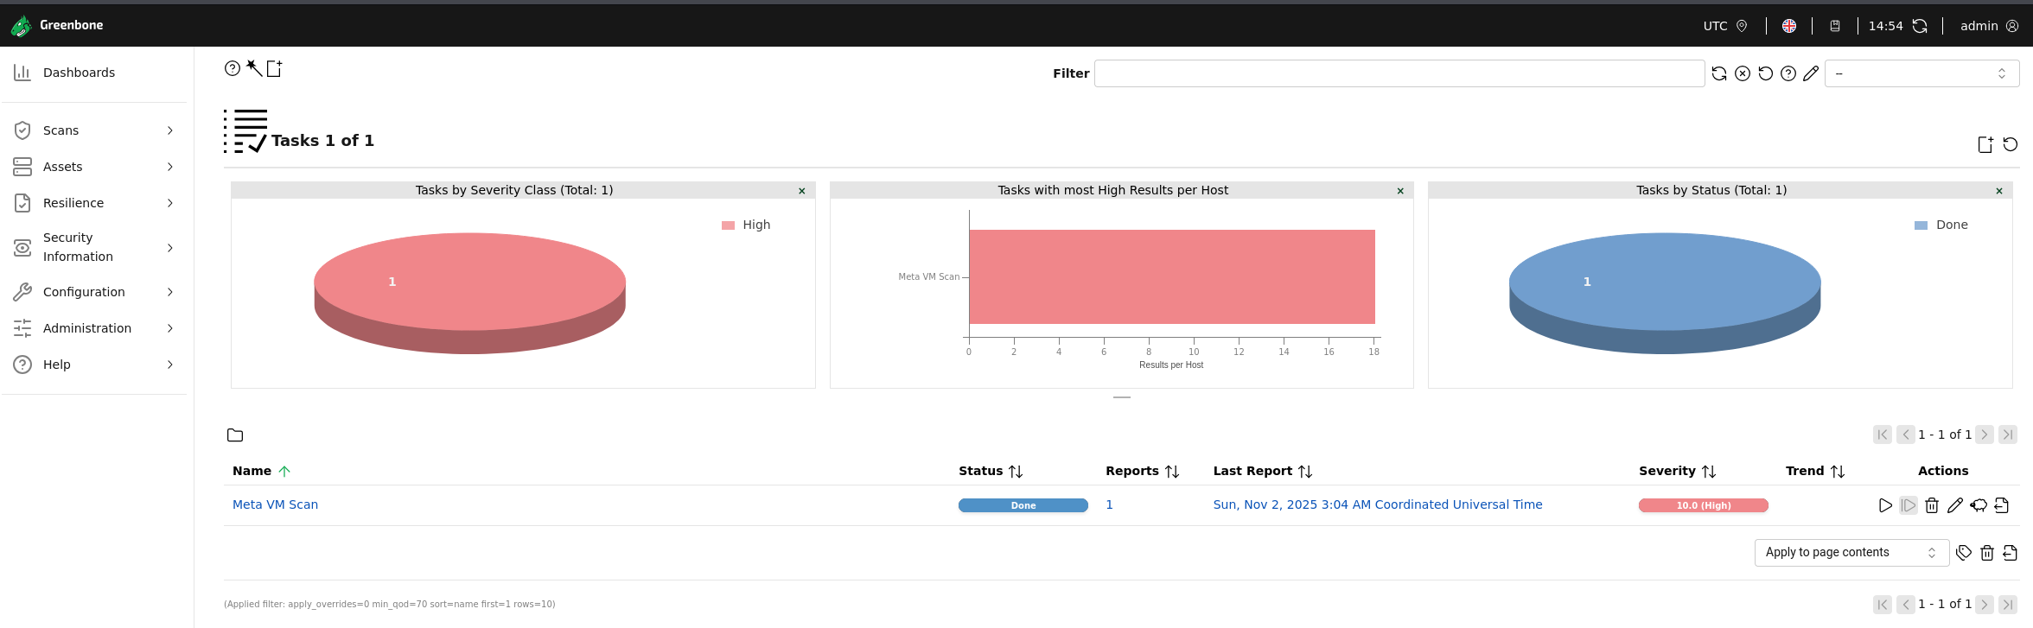
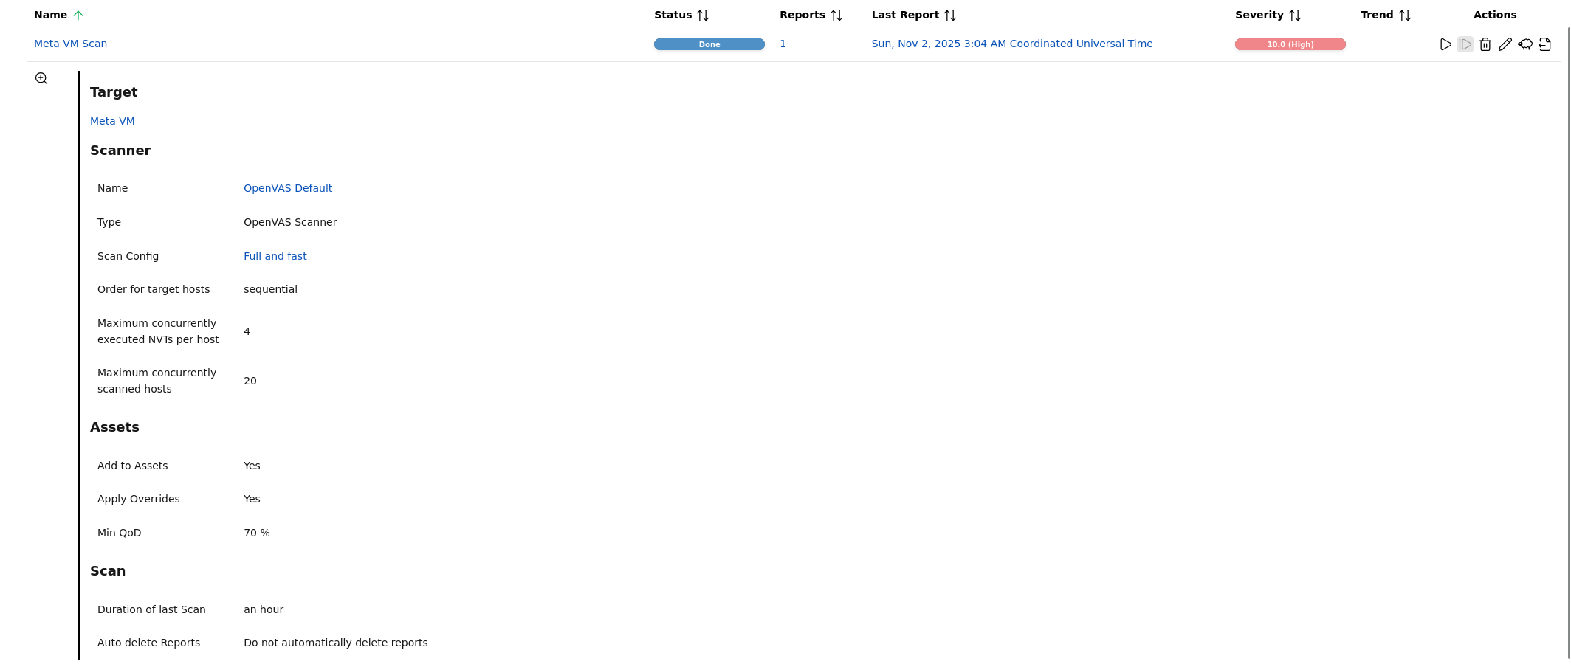
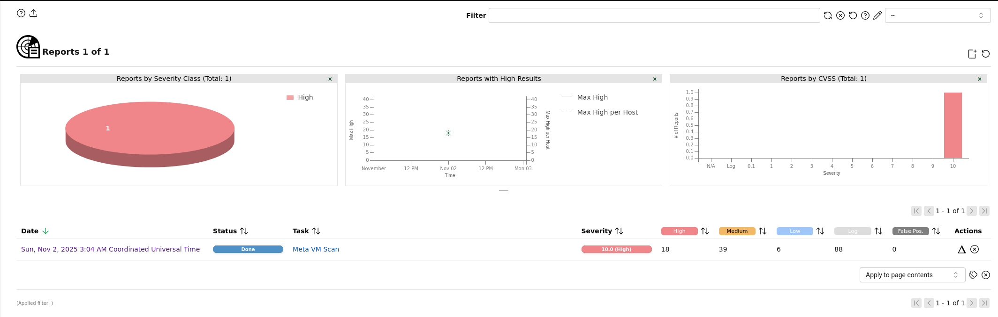
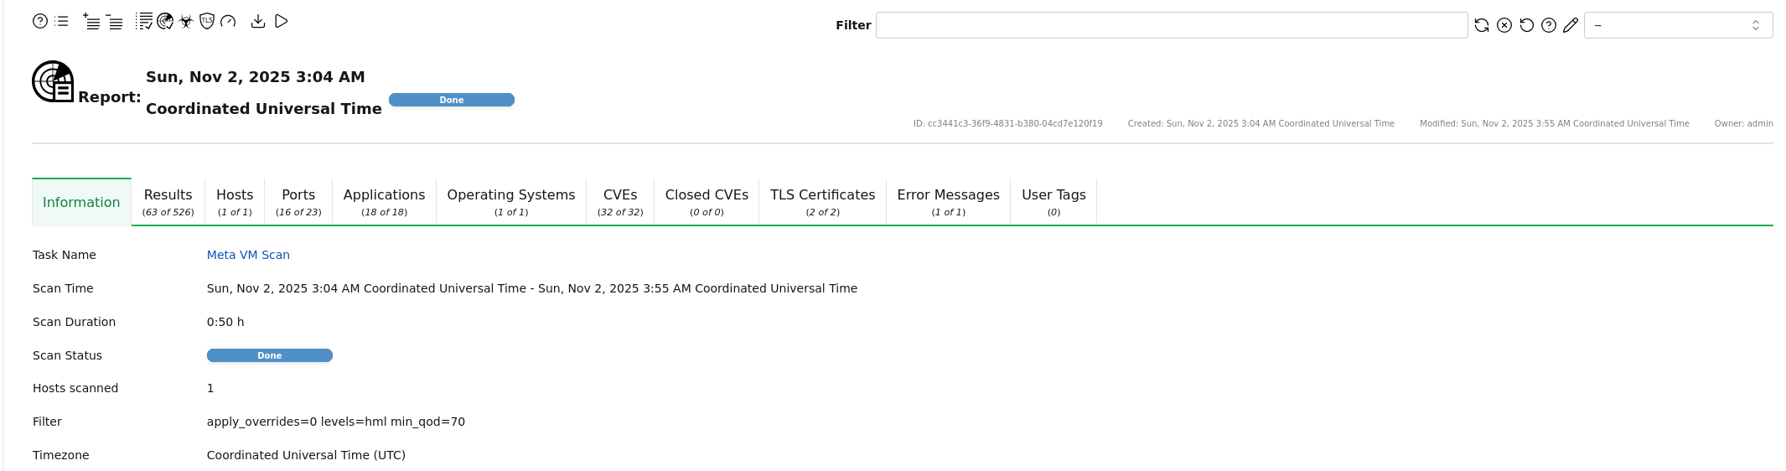
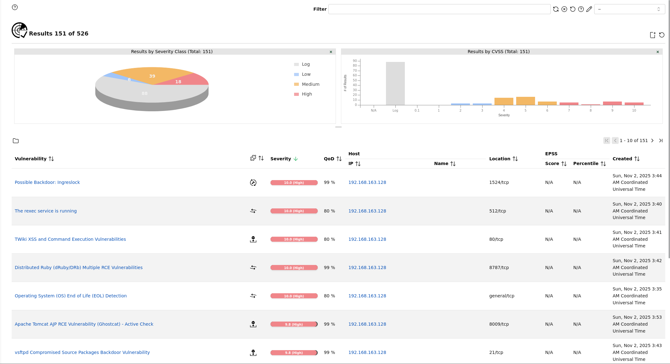
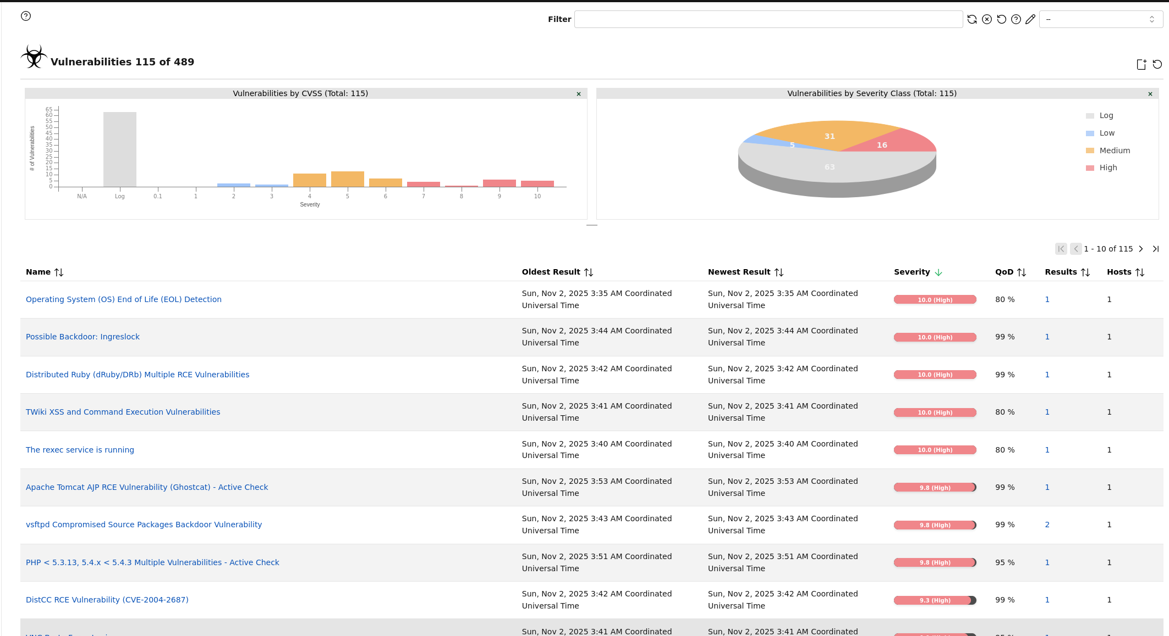

Framework and Components:

Regulatory Requirements
HIPPA Security Rule - https://www.hhs.gov/hipaa/for-professionals/security/index.html
Sets national standard for protecting electronic protected health information (ePHI).

GDPR - https://gdpr-info.eu/
Even though it is based in West Lafayette, Indiana, we must still understand the protection of personal data and privacy for EU residents regardless of where the data is processed.

PCI DSS - https://www.pcisecuritystandards.org/
This is a purchased resource, so it was hard to find exact standards. However, the standard governs the protection of cardholder data during the payment process.

Foundational Frameworks
NIST CSF 2.0 - https://www.nist.gov/publications/nist-cybersecurity-framework-csf-20
Provides a flexible and high-level risk management structure for managing our risks across all data types.

ISO/IEC - https://www.iso.org/standard/27001
Help with information security management. Provides a certifiable recognized management system. Aligns with HIPPA and GDPR requirements.

